**Chatbot Using Amazon Lex**

1. **What are chatbots?**

A Chatbot is a software or an agent or a service which simulates human conversation in natural language through messaging applications, websites, mobile phones, or telephone. They can be programmed to respond to simple keywords or prompts to complex discussions. A Chatbot has two different tasks at the core: analyze the request (identifying the intent of the user) and providing the response.

* 1. **Uses**

Following are some of the chatbot applications, out of the infinite possibilities:

* A chatbot for ordering food that allows customers to order from their office or home.
* A chatbot that answers customer service questions
* A chatbot that allows the customer to book a flight and receive relevant information.
* A chatbot that helps a customer to purchase in eCommerce.
* A chatbot that asks questions to the customer for a marketing campaign.
* A health bot that provides services for booking a Doctor consultation and getting remedies for different symptoms.
* A chatbot that books movie tickets and also provided the reviews.

1. **AWS lex**

To create an Amazon Lex bot

1. Sign in to the AWS Management Console and open the Amazon Lex console at <https://console.aws.amazon.com/lex/>.
2. If this is your first bot, choose **Get Started**; otherwise, on the **Bots** page, choose **Create**.
3. On the **Create your Lex bot** page, provide the following information, and then choose **Create**.

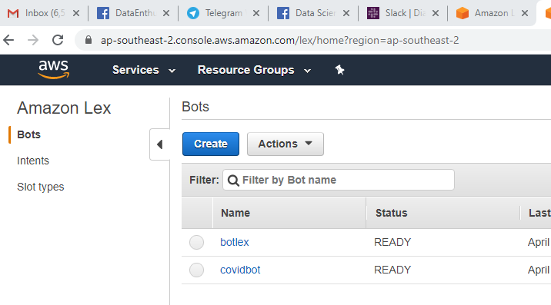

1. Choose **Create**. The console makes the necessary requests to Amazon Lex to save the configuration. The console then displays the bot editor window.
2. Wait for confirmation that your bot was built.

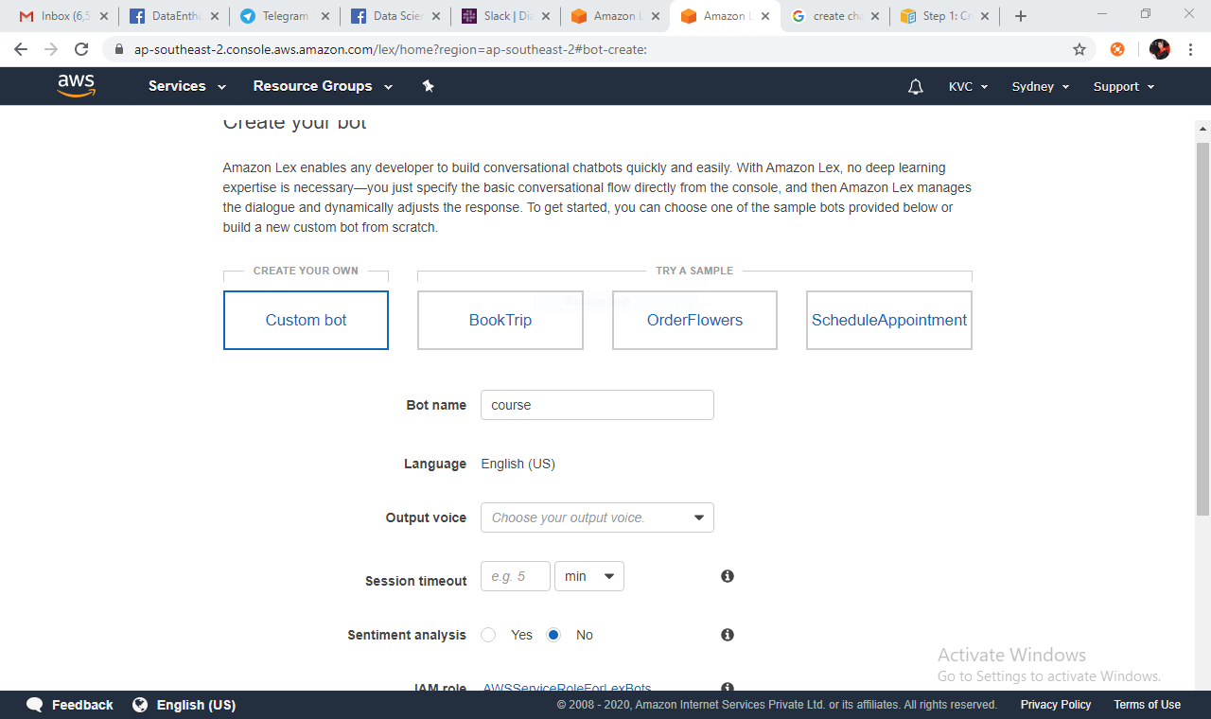

1. Now start creating intent by giving unique names and click on ADD button to create an intent. An intent is what a user is trying to accomplish. Within the code, this is how you define your function. ‘Intent’ doesn’t relate to the specific words that a user says, but the high-level goal they are aiming for. You can also import or browse intents. There are some inbuilt intents also that you can use.

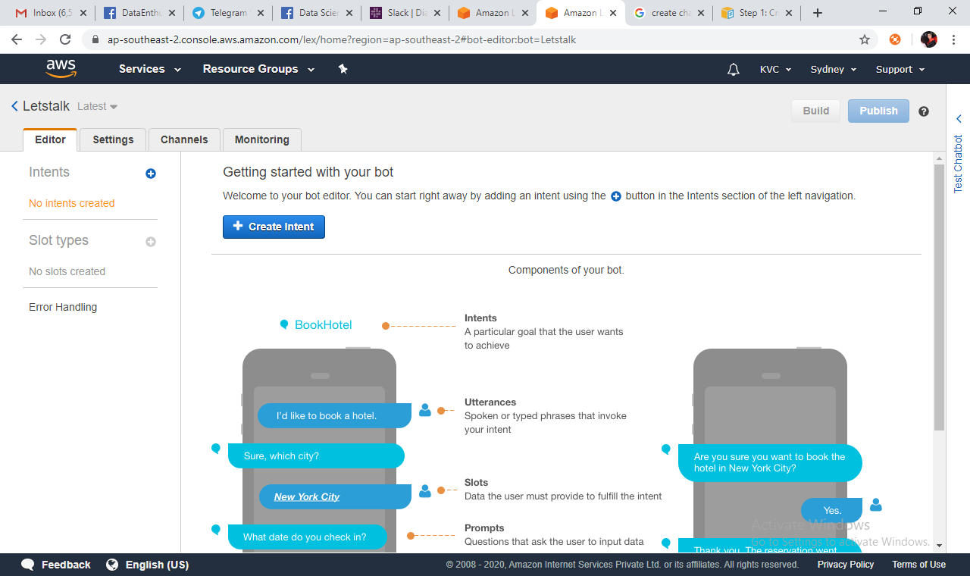

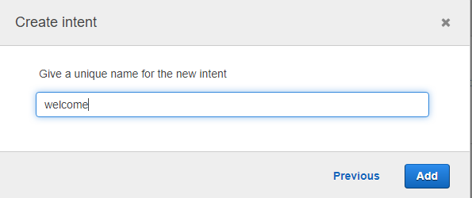

1. Now give sample utterances. Utterances are the specific phrases that people will use when making a request .
2. Now define slots. A slot is a variable that relates to an intent allowing Alexa to understand information about the request. Amazon provides a number of built in slot types, such as dates, numbers, durations, time, etc. But developers can create custom slots for variables which are specific to their skill.

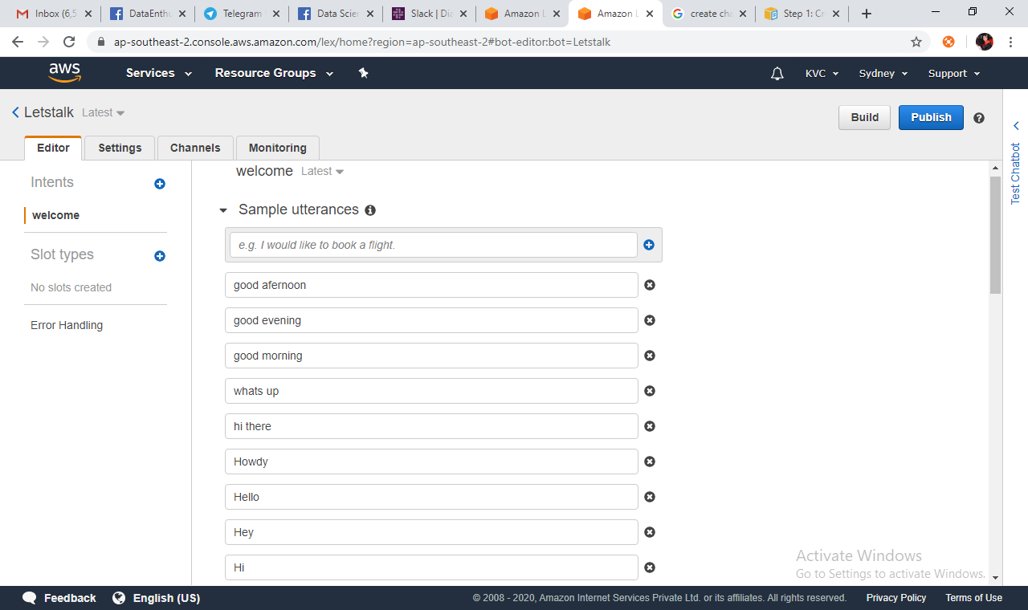

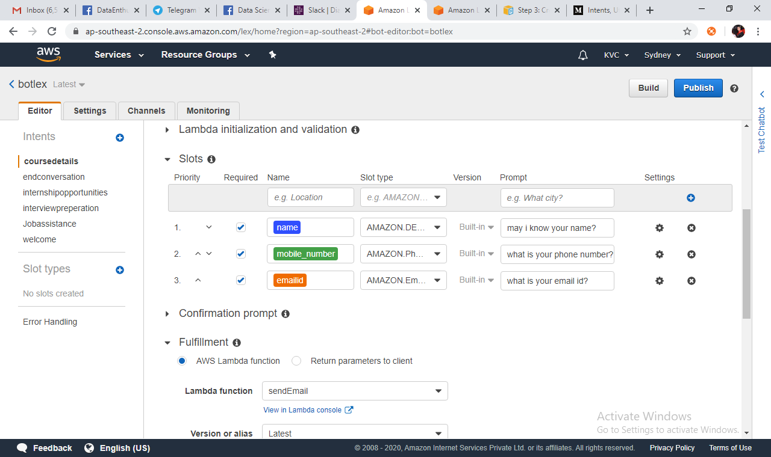

1. Create lambda function

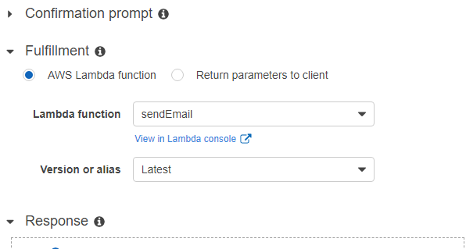

**To create the Lambda function (console)**

Sign in to the AWS Management Console and open the AWS Lambda console at <https://console.aws.amazon.com/lambda/>.

Choose **Create function**.

1. On the **Basic information** page, do the following.
   * Type a Lambda function name (sendEmail).
   * For the execution role, choose **Create a new role with basic Lambda permissions**.
   * Leave the other default values.
2. Choose **Create function**.
3. Test the Lambda function.

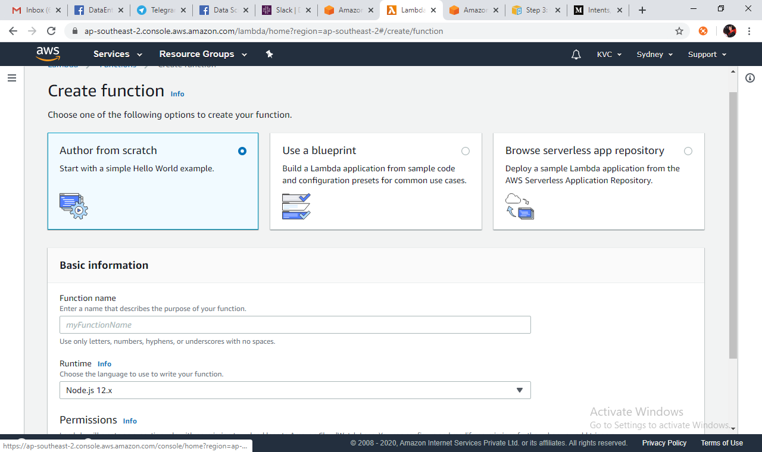

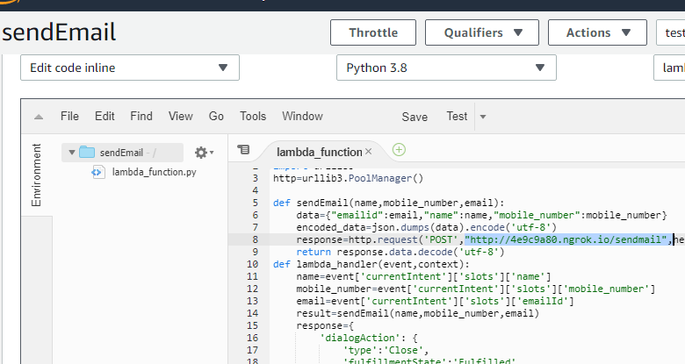

1. Test and Configure the lambda function by choosing configure test event.
   * Choose **Select a test event**, **Configure test events**.
   * Choose **Create**.
   * Choose **Test** to test the code hook.
   * Verify that the Lambda function successfully executed. The response in this case matches the Amazon Lex response model.

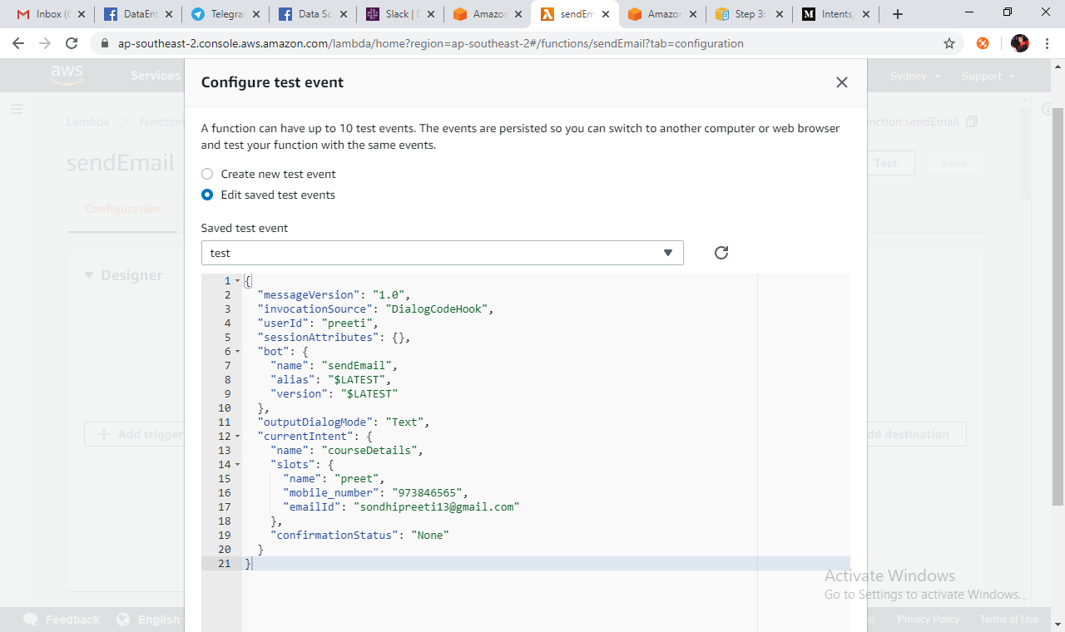

1. Build to test the bot and After you have published all of the slot types and intents that are used by your bot, you can publish the bot. you have to give alias to the bot and it will publish your bot. You can test the bot by typing text into the test window, or, for compatible browsers, by choosing the microphone button in the test window and speaking.

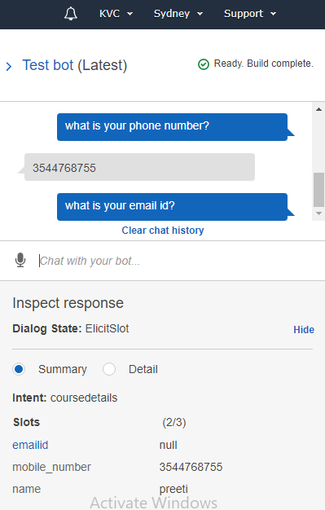

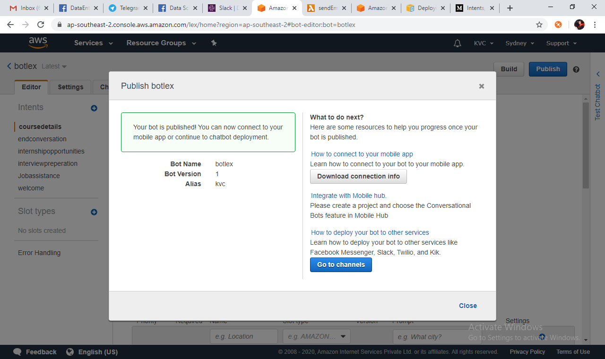

1. **Integration**

3.1 Integration with facebook

Go to channel and select facebook. Type channel name, description, alias and required information. You will get page access token and app secret from facebook page.

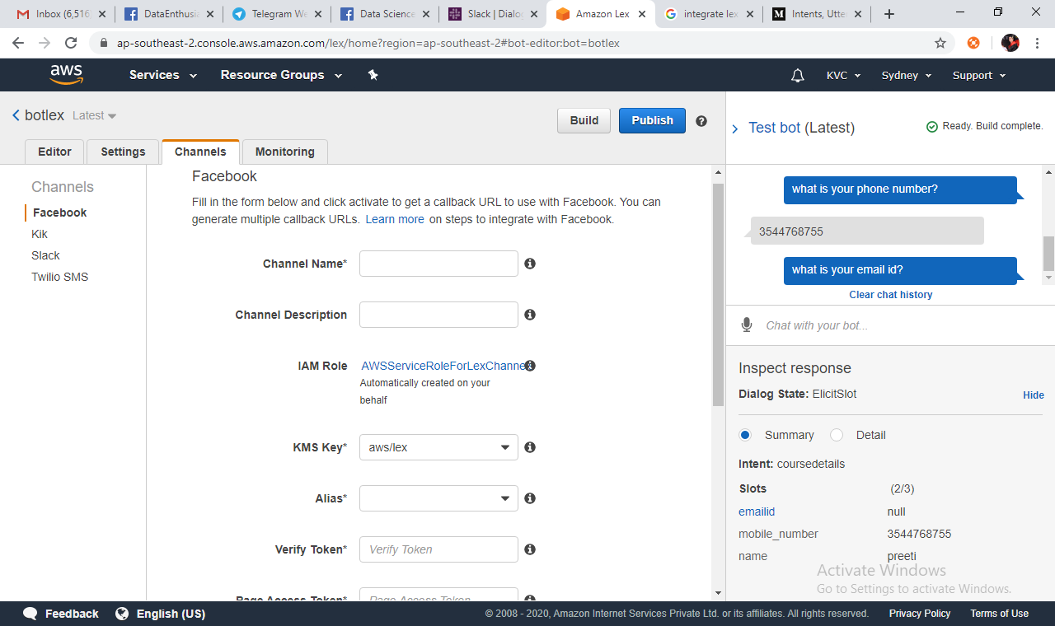

Create an app by sign up at facebook for developers and create a page.

1. On the Facebook developer portal, choose your app or create.
2. Choose the Messenger product, and choose Setup webhooks in the Webhooks section of the page.
3. On the webhook page of the subscription wizard, do the following:
   * For Callback URL, type the callback URL provided in the Amazon Lex console earlier in the procedure.
   * For Verify Token, type the same token that you used in Amazon Lex.
   * Choose Subscription Fields (messages)
   * Choose Verify and Save. This initiates a handshake between Facebook and Amazon Lex.
4. Enable Webhooks integration. Choose the page that you created, and then choose subscribe.

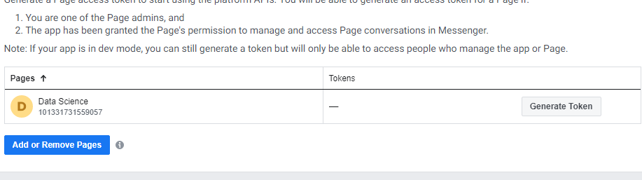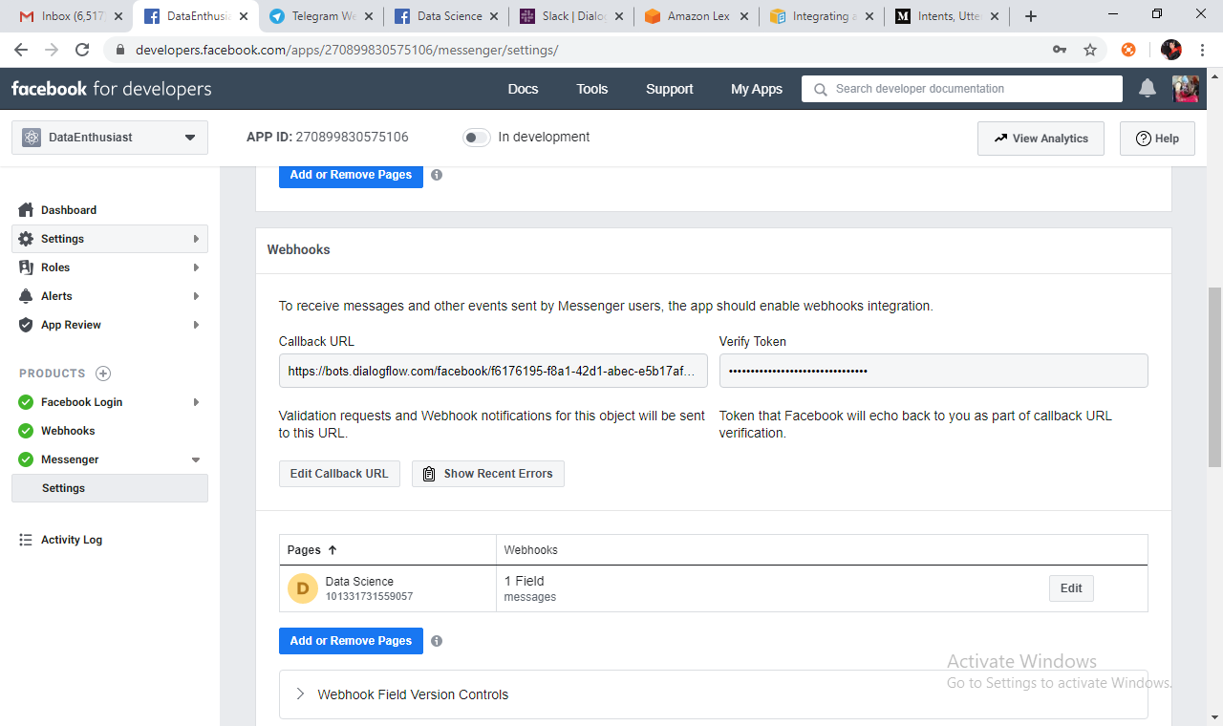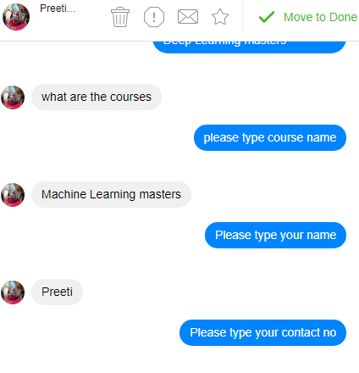

**Integration with Slack**

**Create a slack application**

1. Create a Slack application on the Slack API Console
2. Configure the application to add interactive messaging to your bot:
3. At the end of this section, you get application credentials (Client Id, Client Secret, and Verification Token). In the next section, you use this information to configure bot channel association in the Amazon Lex console.
4. Sign in to the Slack API Console at [http://api.slack.com](http://api.slack.com/).
5. Create an application.
6. After you have successfully created the application, Slack displays the Basic Information page for the application.
7. Configure the application features as follows:
8. In the left menu, choose Interactive Components.
9. Choose the toggle to turn interactive components on.
10. In the Request URL box, specify any valid URL. For example, you can use https://slack.com.

In the left menu, in **Settings**, choose **Basic Information**. Record the following application credentials:

* Client ID
* Client Secret
* Verification Token

